**Thura Aung**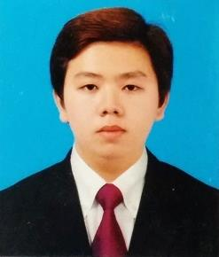

**No.10(A), Thein Gyi St.,**

**Kyimyindine Tsp.,**

**Yangon.**

**Telephone: 09 775-267-951.**

**Email:** [**thuraaung2493@gmail.com**](mailto:thuraaung2493@gmail.com)

**Personal Information**

NRC No: 12/Ka Ma Ta (Pyu) 000081

Gender: Male

Date of Birth: 02.04.1993

Nationality: Chinese + Myanmar

Religion Buddhist

Marital Status: Single

Interest: Reading

Position: Junior Programming (On Job Training)

**Education**

Bachelor of Mechatronic Engineering.

West Yangon Technology University,

Yangon.

2010 – 2015.

**Other Qualification**

* Certificate in Web Professional Foundation
* Certificate in Essential Programming (C++)
* Certificate in Android Development
* Certificate of Competence (Microsoft Office)
* Certificate in Basic Writing
* Certificate in Communication Spoken English
* Certificate in Pre-Intermediate General English
* Certificate in Applied Electronic Course
* Certificate in AutoCAD 2007

**Working Experience**

**Position Company Name Year**

Junior Engineer Myanmar Jardine Schindler 2015 - 2016

**Skills**

* HTML (HTML 5)
* CSS (CSS 3)
* Javascript
* JQuery
* Bootstrap

**Objective**

To seek a challenging position on dynamic environment where I can utilize all of education and, my problem solving skills, public relationship and customer service technique and professional experiences.

**Personal Characteristics**

Leadership Charisma, sense of responsibilities, excellent skills in communication and collaboration, abstainer, communicative, energetic, diligent, possess managerial abilities, disciplined; wish to develop enterprising with sense of humor.

**Profile**

I am high disciplined, efficient and responsible individual. Smart and well presentation with a pleasant and cheerful disposition, well organized and hard-working, capable of working independently in a team oriented situation.